Name=Leela Jayashree

Trainer=Harshee pitroda

Course=python and ML

Date=3/6/22

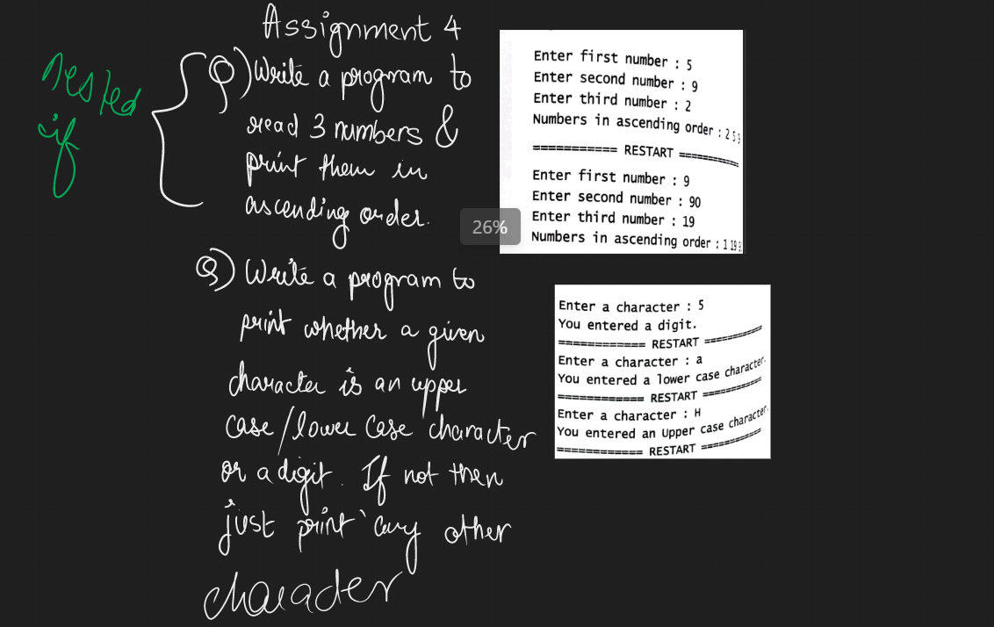

Q1) n1=int(input('enter first number:'))

n2=int(input('enter second number:'))

n3=int(input('enter third number:'))

print('the ascending order of the numbers are:' ,end=" ")

if (n1<n2) and (n1<n3):

print(n1 ,end=" ")

if (n2<n3):

print(n2 ,end=' ')

print(n3)

else:

print(n3 ,end=" ")

print(n2)

if (n2<n1) and (n2<n3):

print(n2 ,end=" ")

if (n1<n3):

print(n1 ,end=" ")

print(n3)

else:

print(n3 ,end=" ")

print(n1)

if (n3<n1) and (n3<n2):

print(n3 ,end=" ")

if (n1<n2):

print(n1 ,end=" ")

print(n2)

else:

print(n2 ,end=" ")

print(n1)

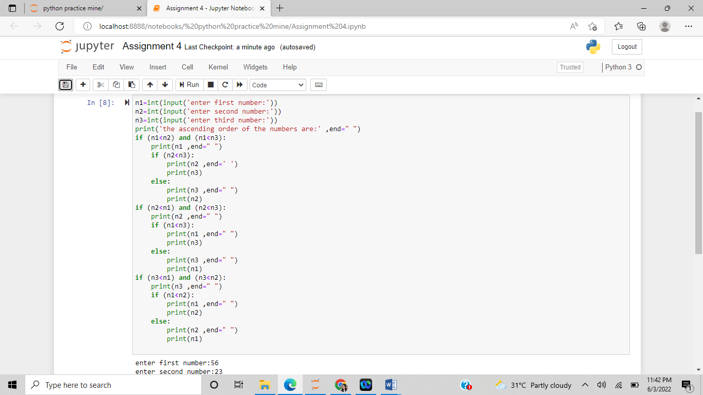

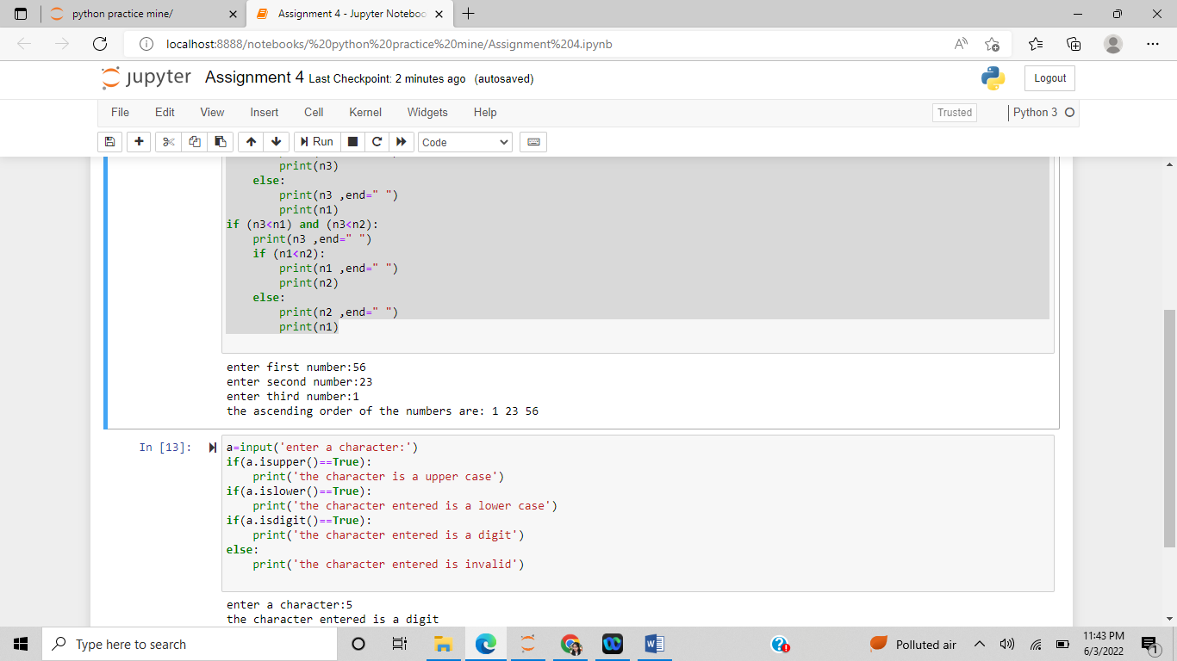

Q2) a=input('enter a character:')

if(a.isupper()==True):

print('the character is a upper case')

if(a.islower()==True):

print('the character entered is a lower case')

if(a.isdigit()==True):

print('the character entered is a digit')

else:

print('the character entered is invalid')

